Andrew Dykman – Software Development Lifecycles – Lab 4

Task 1.)
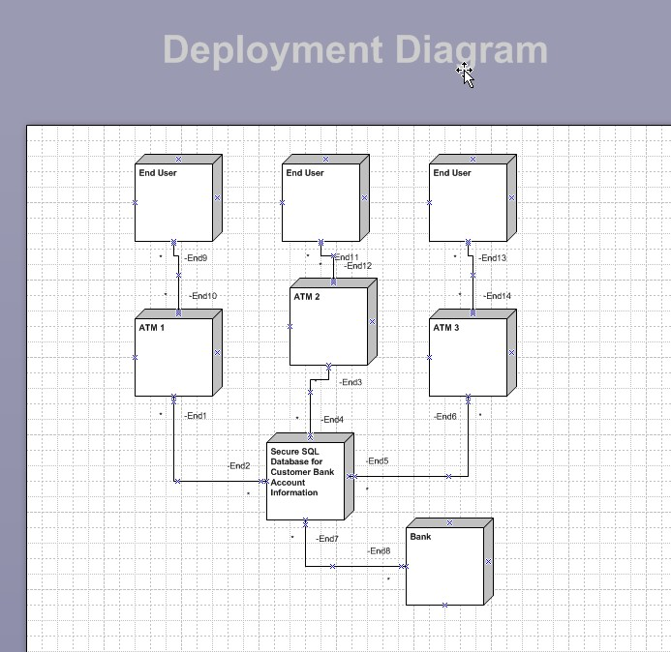
Question A.) The model would change if the system were connected to the internet because every node from which the user or the system would access the internet would have to be assigned an additional communication for a point going out to the internet.

Task 2.)
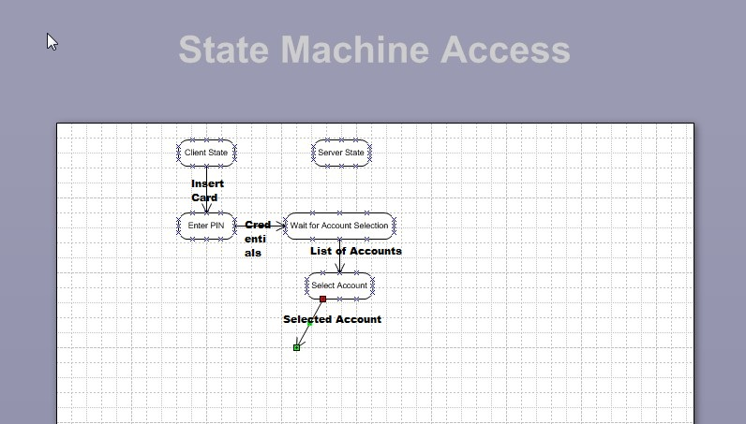
Question B.) No, because these are variations that can occur, and cannot be mapped out in the diagram because they are unknown at the time of the creation of the diagram and subject to change.

